An Interactive Method for Volumetric Human Organ Models on Augmented Reality

Yuna Kim and Sangwha Lee*
Department of Computer Science, Hankok University
Seoul, South Korea
[e-mail: mail1@gmail.com, mail2@gamil.com]
*Corresponding author: Sangwha Lee

Abstract

This paper presents an interactive method to manipulate reconstructed volumetric medical images from medical imagery using Augmented Reality(AR). The proposed system provides a possibility to reconstruct 3D dataset of patients in real-time and overlay the 3D models for manipulating the virtual objects in AR system. For this work, a sequence of CT images from human organ are acquired and segmented to detect region of interest(ROI). Subsequently using the consecutive slices of the segmented image, surface rendering is performed to construct polyhedral 3D surface. The generated 3D surface models are registered specific marker on AR system for the purpose of providing visual information of the organ model in a feasible fashion. By controlling the positions of markers in AR system with ARTookit, the view of the augmented 3D medical model can be dynamically varied.

Keywords: Volumetric medical image, image segmentation, surface reconstruction, Augmented Reality

1. Introduction
Augmented Reality(AR)[1] as a medical image visualization and training tool for doctors has been increased in its usability in medical surgery. In AR environments, it maybe possible to collect 3D dataset of patients in realtime using MRI, CT(Computed Tomography), or ultrasound imaging. These dataset can be rendered and combined with a real view of other objects for minimally invasive surgery or educational purpose in medical field. Physicians can detect some features with naked eye that they cannot see in CT or MRI, and vice-versa. In the training purposes, virtual object can identify organs and specify locations without patients.
Researches in this area primarily focus on tracking and registration quality as well as specific visualizations in support of medical procedure [2,3].
2. Reconstruction of Volumetric Models
2.1 Segmentation of medical Image
The correct image segmentation provides clinically important information to analyze the tissue for physicians as well as to reconstruct 3D volume model based on the segmentation result.
2.2 A Heuristic Polyhedral Surface Model
3D volume of the medical image can be made by using different approaches such as raw image data, deformable surface and polyhedral model [9]. Among them, in this work polyhedral model which is more precisely tetrahedral mesh is used for 3D volume reconstruction.

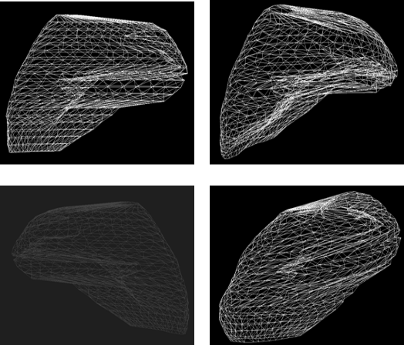
Fig. 1. 3D Reconstructed human liver from CT images
3. Manipulation of Virtual Model
In order to overlay the virtual 3D models on the AR system, a marker in the input image should be detected first.
4. Conclusions
In this paper, we presents an interactive method to manipulate a 3D surface model from CT using Augmented Reality.
References
- S. Nicolau, A. Garcia, X. Pennec, L. Soler, and N. Ayache, “An augmented reality system to guide radio-frequency tumor ablation,” Computer Animation and Virtual World, vol.16, no.1, pp.1-10, 2005.
- K. Gray, L. Ibanez, S. Aylward et al., “Igstk: An open source software toolkit for image-guided surgery,” Computer, vol.39, no.4, pp.46-53, 2006.
- M. Bauer, B. Bruegge, G. Klinker et al., “Design of a component-based augmented reality framework,” in Proc. of International Symposium on Augmented Reality (ISAR), 2001.

